API OVERVIEW
AND API REFERENCE
Star Wars API (SWAPI)

API OVERVIEW

Introduction
The Star Wars API (SWAPI) provides access to structured data about the Star Wars universe. Users can retrieve information about planets, spaceships, vehicles, people, films and species by sending HTTP requests to the API.
SWAPI returns resource data in JSON format. The API is publicly accessible and does not require authentication to retrieve data.

Getting Started
To get started with SWAPI, send a GET request to API. You can use tools such as cURL or httpie to make requests.
For example, the following request retrieves information about the planet Tatooine:
https://swapi.py4e.com/api/planets/1/
Response in httpie:
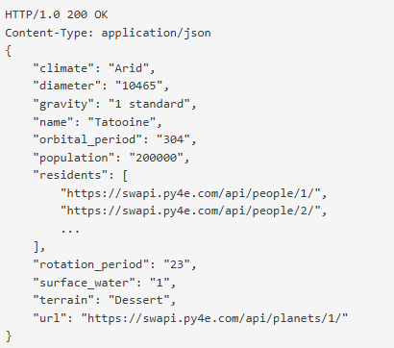

Base URL
The base URL is the root address used to access all APIs.
https://swapi.py4e.com/api/
Append the appropriate resource endpoint to the base URL to construct a complete request URL.
For example:
https://swapi.py4e.com/api/people/1/
This endpoint retrieves information about the person identified by ID 1.

Rate Limiting
SWAPI limits requests by IP address to help prevent misuse and handle large amount of traffic. The rate limit is 10,000 requests per day per IP address. This limit is sufficient to retrieve all the data from the website.

Authentication
SWAPI does not require authentication to retrieve data. If you face any issue, contact support team.

Request and Response format
SWAPI uses JavaScript Object Notation (JSON) schema by default for request and response. It allows user to inspect the attributes of the resource and their types.
Wookiee users can append “?format=wookiee” to a request URL.
For example:
https://swapi.py4e.com/api/planets/1/?format=wookiee

Searching resources
SWAPI supports a search query parameter for filtering resources. Search terms are matched case-insensitively and can return partial matches for supported fields.
For example:
https://swapi.py4e.com/api/people/?search=r2

API REFERENCE
This section provides information for two endpoints from people resource.
They are:
- GET /people/ -- fetches a list of people
- GET /people/:id/ -- fetches details of a specific person.

- GET – Fetches a list of people
- Resource
People
- Introduction
Retrieves details of people
- Method
GET
- Base URL
swapi.py4e.com/api/
- Request URL
https://swapi.py4e.com/api/people/
- Path Parameter table
Parameter | Required/Optional | Data Type | Values | Description of the parameter
search | Required | String |  | Filters person by name

- Response parameter
Parameter | Child parameters | Data Type | Values | Description of the parameter
count |  | Int64 |  | Total number of people.
next |  | string |  | URL of the next page.
previous |  | null |  | URL of the previous page.
results | name | string |  | Name of the person.
 | height | string |  | Height of the person in centimeters.
 | mass | string |  | Mass of the person in kilograms.
 | hair_color | String | - color  - unknown  - n/a | Hair color of the person.  Values:  - color – mention the hair color  - unknown – hair color is not known  - n/a – person does not have hair.
 | skin_color | string |  | Skin color of the person.
 | eye_color | string | - color  - unknown  - n/a | Eye color of the person.  Values:  - color – mention the eye color  - unknown – eye color is not known  - n/a – person does not have an eye.
 | birth_year | string |  | Birth year of the person, using the star wars calendar.  (BBY- Before the Battle of Yavin or  ABY - After the Battle of Yavin)  For example: 19BBY.
 | gender | string | - male  - female  - unknown  - n/a | Gender of the person.  Values:  - male – the person is male  - female – the person is female  - unknown – gender is not known  - n/a – gender is not applicable.
 | homeworld | string |  | URL of the planet where the person was born.
 | films | array |  | URLs of films featuring the person.
 | species | array |  | URLs of species belong to the person.
 | vehicles | array |  | URLs of vehicles the person has piloted.
 | starships | array |  | URLs of starships the person has piloted.
created |  | string |  | Date and time when the resource was created.
edited |  | string |  | Date and time when the resource was last edited.
url |  | string |  | URL of the resource.

- Response/Example JSON
{
"count": 87,
"next": "https://swapi.py4e.com/api/people/?page=2",
"previous": null,
"results": [
{
"name": "Luke Skywalker",
"height": "172",
"mass": "77",
"hair_color": "blond",
"skin_color": "fair",
"eye_color": "blue",
"birth_year": "19BBY",
"gender": "male",
"homeworld": "https://swapi.py4e.com/api/planets/1/",
"films": [
"https://swapi.py4e.com/api/films/1/",
"https://swapi.py4e.com/api/films/2/",
"https://swapi.py4e.com/api/films/3/",
"https://swapi.py4e.com/api/films/6/",
"https://swapi.py4e.com/api/films/7/"
],
"species": [
"https://swapi.py4e.com/api/species/1/"
],
"vehicles": [
"https://swapi.py4e.com/api/vehicles/14/",
"https://swapi.py4e.com/api/vehicles/30/"
],
"starships": [
"https://swapi.py4e.com/api/starships/12/",
"https://swapi.py4e.com/api/starships/22/"
],
"created": "2014-12-09T13:50:51.644000Z",
"edited": "2014-12-20T21:17:56.891000Z",
"url": "https://swapi.py4e.com/api/people/1/"
}
]
}

- Postman testing screenshot for people
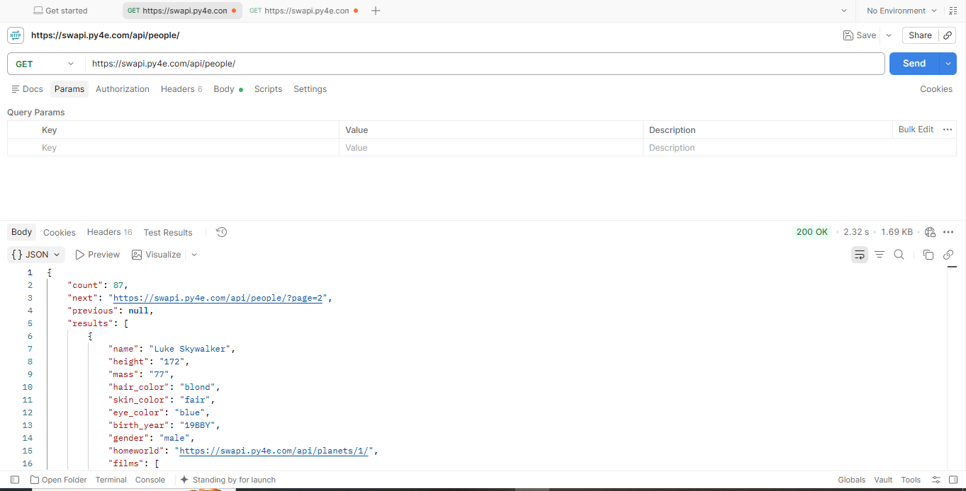

- Get – Fetches details of a specific person
- Resource
People
- Introduction
Retrieves details of a specific person using unique ID.
- Method
GET
- Base URL
swapi.py4e.com/api/

- Request URL
https://swapi.py4e.com/api/people/{id}/
- Example URL
https://swapi.py4e.com/api/people/1/

- Path Parameter
Parameter | Required/Optional | Data Type | Values | Description of the parameter
id | Required | Int64 |  | Unique id of the person.

- Response parameter
Parameter | Child parameters | Data Type | Values | Description of the parameter
name | - | string |  | Name of the person.
height | - | string |  | Height of the person in centimeters.
mass | - | string |  | Mass of the person in kilograms.
hair_color | - | String | - color  - unknown  - n/a | Hair color of the person.  Values:  - color – mention the hair color  - unknown – hair color is not known  - n/a – person does not have hair.
skin_color | - | string |  | Skin color of the person.
eye_color | - | string | - color  - unknown  - n/a | Eye color of the person.  Values:  - color – mention the eye color  - unknown – eye color is not known  - n/a – person does not have an eye.
birth_year | - | string |  | Birth year of the person, using the star wars calendar.  (BBY- Before the Battle of Yavin or  ABY - After the Battle of Yavin)  For example: 19BBY.
gender | - | string | - male  - female  - unknown  - n/a | Gender of the person.  Values:  - male – the person is male  - female – the person is female  - unknown – gender is not known  - n/a – gender is not applicable.
homeworld | - | string |  | URL of the planet where the person was born.
films | - | array |  | URLs of films featuring the person.
species | - | array |  | URLs of species belong to the person.
vehicles | - | array |  | URLs of vehicles the person has piloted.
starships | - | array |  | URLs of starships the person has piloted.
created | - | string |  | Date and time when the resource was created.
edited | - | string |  | Date and time when the resource was last edited.
url | - | string |  | URL of the person resource.

- Response/Example JSON
{
"name": "Luke Skywalker",
"height": "172",
"mass": "77",
"hair_color": "blond",
"skin_color": "fair",
"eye_color": "blue",
"birth_year": "19BBY",
"gender": "male",
"homeworld": "https://swapi.py4e.com/api/planets/1/",
"films": [
"https://swapi.py4e.com/api/films/1/",
"https://swapi.py4e.com/api/films/2/",
"https://swapi.py4e.com/api/films/3/",
"https://swapi.py4e.com/api/films/6/",
"https://swapi.py4e.com/api/films/7/"
],
"species": [
"https://swapi.py4e.com/api/species/1/"
],
"vehicles": [
"https://swapi.py4e.com/api/vehicles/14/",
"https://swapi.py4e.com/api/vehicles/30/"
],
"starships": [
"https://swapi.py4e.com/api/starships/12/",
"https://swapi.py4e.com/api/starships/22/"
],
"created": "2014-12-09T13:50:51.644000Z",
"edited": "2014-12-20T21:17:56.891000Z",
"url": "https://swapi.py4e.com/api/people/1/"
}

- Postman testing screenshot for specific person
